



Intelligent Vehicle Price Prediction & Search Engine

Prepared By:
Amir Mansour Eid Mohammed (352250721)
Muhammed Amr Muhammed Hasan (352250964)
Hazem Amr Mohammed (352250744)
Hazem Elsayed Abou Elwafaa (352250742)
Zeyad Sayed Mohammed (352250778)
Seif Hatem Abdelhaleem (352250797)

Supervised By:
Dr. Ahmed Madboly

Acknowledgement

We would like to express our sincere gratitude to our supervisor Dr. Ahmed Madboly for his continuous guidance, valuable feedback, and strong academic support throughout the development of this project. His expertise in machine learning and data analysis greatly contributed to improving the quality and direction of this work.

We also extend our appreciation to the authors of the research paper:
“An Analysis of Car Price Prediction using Machine Learning”
Parth Bhatnagar, Gururaj H. L., Shreyas J., Francesco Flammini, Shivansh Gautam
ICMLT 2024, 9th International Conference on Machine Learning Technologies, Oslo, Norway, May 24–26, 2024
📄 https://dl.acm.org/doi/10.1145/3674029.3674032
🔗 https://doi.org/10.1145/3674029.3674032

Their study provided a strong theoretical and practical foundation for this project, particularly in applying regression and ensemble learning techniques for car price prediction. Additionally, the dataset used in their research is widely recognized and has been utilized in more than 120 academic studies, highlighting its reliability and significance in the field of machine learning and automotive analytics.
Finally, we thank our institution for providing the necessary academic environment, tools, and resources, and we are grateful to our families for their continuous encouragement and support.

Abstract
This research paper explores machine learning techniques, such as voting regressors, gradient boosting regressors, random forest regressors, decision tree regressors, support vector regressors, CatBoost, LightGBM, and XGBoost, for predicting car prices. Each machine learning technique has its own unique advantages and limitations, with ensemble-based methods showing the strongest predictive performance.
Methodologically, GridSearchCV is used to tune hyperparameters on a dataset of more than 200 automobiles, each containing 26 features describing vehicle specifications and attributes. The outcomes demonstrate the strong predictive capability of regression and ensemble learning techniques, providing valuable insights for both academic researchers and industry practitioners.

Experimental results show that advanced boosting algorithms outperform traditional models and even surpass the results reported in the referenced study. Specifically, CatBoost achieved an accuracy of 0.943021, LightGBM achieved 0.942441, and XGBoost achieved 0.941069, all of which demonstrate improved performance compared to prior research benchmarks.

These results highlight the effectiveness of gradient boosting-based methods in capturing complex nonlinear relationships between vehicle features and price. Overall, the study confirms that modern ensemble learning techniques significantly enhance prediction accuracy and provide more reliable estimations for real-world car pricing applications.

Chapter 1: Introduction

1.1 Background: The Automotive Industry and Data-Driven Pricing
The automobile industry has undergone significant changes in recent years due to the introduction of data-driven decision-making processes, changing consumer tastes, and technical improvements. Vehicle prices are determined by a complex interplay of factors including market demand, production costs, prevailing economic conditions, fuel trends, and the rapidly evolving regulatory landscape for emission standards and electrification.
The global automotive market represents one of the largest economic sectors worldwide, generating revenues exceeding USD 3 trillion annually. Within this ecosystem, the used and pre-owned vehicle segment has grown substantially, driven by rising new-car prices, improved vehicle longevity, and the proliferation of digital marketplaces that have made second-hand car trading accessible to millions of consumers who previously lacked access to organized markets.
In India — the geographic context of this research, anchored at Manipal Institute of Technology Bengaluru — the automotive market has seen particularly dynamic growth. India is among the world's top five automotive markets, and the used car market is estimated to be twice the size of the new car market in terms of units. Accurate vehicle pricing in this context is not merely a commercial convenience but a socioeconomic imperative, affecting purchase decisions for millions of consumers who depend on pre-owned vehicles as their primary mode of transport.

1.2 Motivation: Why Machine Learning for Car Pricing?
Traditional vehicle pricing methodologies suffer from several critical limitations. Published price guides and manufacturer suggested retail prices (MSRPs) fail to account for the unique combination of condition, mileage, regional market dynamics, and historical ownership of individual vehicles. Human appraisers, while experienced, introduce subjectivity, inconsistency, and scalability constraints. Neither approach is capable of processing the multi-dimensional, non-linear relationships between vehicle attributes and market price that modern machine learning algorithms can exploit.
Predictive modelling brings a potential revolution to the automotive pricing process. It gives buyers knowledge about fair market values, helping them make informed judgments about what to purchase. Simultaneously, it helps producers and dealers improve their pricing strategies and streamline inventory control — reducing days-on-lot, improving profit margins, and enhancing customer satisfaction through price transparency.
Machine learning algorithms, trained on large historical transaction datasets, can automatically identify patterns, interactions, and non-linearities in pricing data that would be impossible to codify in traditional rule-based systems. Furthermore, such models can be retrained continuously as market conditions evolve, ensuring predictions remain current and relevant.

1.3 Research Problem and Complexity
While the value proposition of ML-based car price prediction is clear, its implementation poses substantial technical and methodological challenges:
- High Feature Dimensionality: The dataset used in this research encompasses 26 parameters per vehicle, spanning categorical, ordinal, and continuous numerical types requiring careful preprocessing.
- Non-Linear Relationships: The relationship between vehicle characteristics and price is demonstrably non-linear — for example, the marginal impact of additional horsepower on price depends strongly on the vehicle's market segment.
- Overfitting Risk: Models trained on limited historical data (2,000+ records in this study) are susceptible to memorizing training patterns rather than generalizing to unseen vehicles.
- Hyperparameter Sensitivity: Each algorithm's performance depends critically on its hyperparameter configuration, necessitating systematic tuning approaches such as GridSearchCV.
- Categorical Cardinality: Features like CarName and enginetype have numerous unique values requiring thoughtful encoding strategies to avoid dimensionality explosion.
- Performance Metric Selection: Different applications require emphasis on different metrics — a dealership may prioritize minimizing large errors (RMSE), while a consumer app may prefer minimizing average deviation (MAE/MAPE).

1.4 Research Objectives
This project defines and pursues the following specific, measurable objectives:
- Conduct a comprehensive review of prior research on machine learning-based car price prediction, identifying methodological trends and research gaps.
- Collect, preprocess, and analyse a dataset of 2,000+ automobiles with 26 features per record, applying rigorous data cleaning, encoding, and normalization techniques.
- Implement six machine learning regression algorithms: Linear Regression, Decision Tree Regressor, Random Forest Regressor, Gradient Boosting Regressor, Voting Regressor, and Support Vector Regressor.
- Apply GridSearchCV for systematic hyperparameter optimization to maximize each model's predictive performance.
- Evaluate all models using consistent training and testing accuracy metrics (percentage accuracy and MAPE for Linear Regression), presented in a comparative framework.
- Identify the best-performing model for practical deployment and analyse feature importance across algorithms to provide interpretable insights.
- Discuss future research directions including deep learning integration and real-time market data incorporation.

1.5 Scope and Delimitations
This research focuses on regression-based supervised machine learning approaches for automobile price prediction. The dataset used represents a cross-sectional snapshot of vehicle attributes and prices; the study does not address time-series forecasting of price trajectories or real-time market monitoring. Deep learning architectures (CNN, RNN) are identified as future work directions but are not implemented in the current study. The research targets a general-purpose model applicable across car types, rather than segment-specific models for luxury, electric, or commercial vehicles.

1.6 Structure of the Document
The remainder of this document is organized as follows: Chapter 2 reviews related literature; Chapter 3 identifies real-world applications; Chapter 4 describes the dataset; Chapter 5 details data preprocessing; Chapter 6 presents exploratory data analysis; Chapter 7 covers feature engineering; Chapter 8 describes all six machine learning models; Chapter 9 presents evaluation results; Chapter 10 discusses findings; Chapter 11 addresses deployment; Chapter 12 concludes with future work; and the final section presents UML system design diagrams.

Chapter 2: Literature Review

2.1 Overview of Prior Research in Car Price Prediction
The domain of automotive price prediction has attracted sustained academic interest, with research intensifying over the past decade as large-scale vehicle listing datasets became publicly available. The literature spans classical econometric approaches, traditional machine learning, and most recently deep learning architectures applied to both new and used car price estimation.

2.2 Summary of Referenced Studies

2.2.1 Random Forest for Used Car Price Prediction (Jin, 2021)
Jin [1] investigates used car price prediction by considering factors such as mileage, year of manufacture, fuel consumption, transmission type, tax, fuel type, and engine size. The study was presented at the 2021 IEEE International Conference on Emergency Science and Information Technology. The most accurate regression approach was found to be Random Forest Regression, achieving an R-squared value of 0.90416 — demonstrating strong predictive power and establishing Random Forest as a leading baseline for subsequent comparative studies in this domain.

2.2.2 Linear Regression with Scikit-Learn (Venkatesan et al., 2023)
Venkatesan, Handa, and Baskar [2] emphasize the importance of pricing accuracy for car sales performance and profitability. Their approach employs linear regression implemented using the Scikit-Learn library, with careful data preprocessing and feature adjustments to improve model precision. The study demonstrates that even relatively simple linear models, when properly tuned with domain-relevant features, can provide useful pricing benchmarks for the automotive industry.

2.2.3 K-Nearest Neighbor Regression (Samruddhi & Kumar, 2020)
Samruddhi and Kumar [3] address the expanding market for used vehicles and the importance of accurately estimating residual vehicle value. The study presents a supervised machine learning technique using the K-Nearest Neighbor (KNN) regression algorithm. Their work highlights KNN's instance-based learning approach, which prices a vehicle by reference to the most similar historical transactions, providing intuitive results though with limitations in scalability and computational efficiency for large datasets.

2.2.4 Multi-Algorithm Comparison with Consumer Survey Data (Selvarathi et al., 2023)
Selvarathi, Bhava Dharani, and Pavithra [4] examine car price prediction considering make, model, age, mileage, and vehicle quality as key determinants. Uniquely, this study incorporates consumer survey data alongside technical specifications to capture demand-side pricing signals. Multiple machine learning methods are evaluated including Support Vector Machine, Random Forest, and Linear Regression, providing a consumer-centric perspective on automotive valuation.

2.2.5 Lasso, Multiple Regression, and Regression Trees (Venkatasubbu & Ganesh, 2019)
Venkatasubbu and Ganesh [5] contextualise their work against the backdrop of global automobile production surpassing 70 million passenger cars in 2016, which correspondingly expanded the used car market. Their research evaluates advanced machine learning algorithms including Lasso Regression, Multiple Regression, and Regression Trees, noting the importance of regularization techniques like Lasso in managing high-dimensional feature spaces and preventing overfitting.

2.2.6 Machine Learning and Personalized Recommendation Systems (Chandak et al., 2019)
Chandak et al. [6] discuss the evolution of machine learning in commercial applications, moving beyond pattern recognition toward personalized recommendation and pricing systems. The study investigates how user purchasing patterns can be leveraged through machine learning to improve pricing strategies, offering a broader perspective on data-driven decision systems applicable to automotive e-commerce platforms.

2.2.7 Multiple Linear Regression for Resale Value (Hankar et al., 2022)
Hankar, Birjali, and Beni-Hssane [7] examine the widespread commercial application of Multiple Linear Regression (MLR) for forecasting resale values of used vehicles. Their supervised machine learning case study incorporates variables such as mileage, fuel type, financial power, make, model, and production year — a feature set closely aligned with this project's dataset, providing a useful methodological reference point.

2.2.8 Croatian Used Car Market — 95% Accuracy (Bukvić et al., 2022)
Bukvić, Pašagić Škrinjar, Fratrović, and Abramović [8] investigate data-driven algorithms for estimating used car prices in the Croatian market using data sourced from the 'Njuškalo' marketplace. Their data mining methodology achieves 95% forecast accuracy, notably emphasizing the significance of pricing strategy and vehicle type as dominant predictors. This study demonstrates that geographically specific models can achieve high accuracy when trained on region-appropriate data.

2.2.9 XGBoost for Moroccan Market — R² of 90.7% (Benabbou et al., 2022)
Benabbou, Sael, and Herchy [9] address the Moroccan used car market, presenting a comprehensive preprocessing pipeline and feature engineering methodology tailored to local market conditions. Among all supervised learning methods evaluated, XGBoost demonstrated superior performance with an R² of 90.7%, confirming gradient boosting as a consistently strong approach across diverse geographic markets.

2.2.10 Mathematical Model for Consumer Decision Support (Satapathy et al., 2022)
Satapathy, Vala, and Virpariya [10] focus on developing a dependable mathematical model for precisely projecting used car prices, providing consumers with trustworthy tools for making educated purchase decisions. The research employs sophisticated data analysis alongside machine learning techniques, emphasizing the importance of model reliability and interpretability for end-user trust.

2.3 Comparative Analysis of Prior Literature
Ref. | Authors (Year) | Algorithm(s) | Dataset | Best Metric | Market
[1] | Jin (2021) | Random Forest | UK Cars | R²=0.904 | UK
[2] | Venkatesan et al. (2023) | Linear Regression | Custom | Baseline | India
[3] | Samruddhi & Kumar (2020) | KNN | Used Cars | High Acc. | India
[5] | Venkatasubbu & Ganesh (2019) | Lasso, MLR, RT | Global | Moderate | Global
[8] | Bukvić et al. (2022) | Data Mining | Njuškalo DB | 95% Acc. | Croatia
[9] | Benabbou et al. (2022) | XGBoost | Moroccan Cars | R²=0.907 | Morocco
Ours | Bhatnagar et al. (2024) | 6 algorithms + VR | 2000+ cars, 26 features | Train 97.84% | India/ICMLT
Table 2.1: Summary Comparison of Related Literature

2.4 Research Gaps Addressed by This Study
Analysis of the surveyed literature reveals several persistent gaps that this project directly addresses:
- Lack of multi-algorithm comparative frameworks: Most studies evaluate 1–3 algorithms. This project evaluates six algorithms under identical conditions with systematic hyperparameter tuning.
- Absence of ensemble aggregation: While Random Forest appears frequently, Voting Regressors combining multiple base estimators are rarely studied in the automotive pricing context.
- Insufficient hyperparameter tuning: Many studies use default algorithm parameters, leaving substantial performance gains unrealized. This project employs GridSearchCV across all models.
- Limited feature importance analysis: Few studies provide comparative feature importance rankings across multiple algorithms simultaneously, limiting the generalizability of their interpretability findings.
- Narrow scope of accuracy reporting: Studies typically report a single metric. This project provides both training and testing accuracy for all models, enabling rigorous assessment of overfitting.

Chapter 3: Real-World Use Cases

The Car Price Prediction System has direct, tangible applications across multiple sectors of the automotive ecosystem. This chapter describes three primary real-world use cases, structured around the problem each stakeholder faces, how the ML-based solution addresses it, and the anticipated business and social impact.

Use Case 1: Car Dealership Inventory Pricing

3.1.1 The Problem
Car dealerships maintain dynamic inventories of vehicles ranging from budget compact cars to luxury SUVs. Pricing each unit accurately is a mission-critical business function: overpricing leads to extended inventory holding periods (increasing floor plan interest costs), while underpricing sacrifices gross profit margin. Traditional pricing relies on sales staff intuition, published price guides, and competitor observation — approaches that are subjective, time-consuming, and prone to individual bias.
In the Indian automotive retail context, mid-sized dealerships manage 100–400 active used car listings simultaneously. Without systematic pricing tools, price inconsistencies across the inventory erode consumer trust and create internal pricing conflicts between sales and finance teams.

3.1.2 The ML Solution
By integrating the trained Gradient Boosting or Random Forest model (the best performers in this study) into the dealership's vehicle management system, pricing managers can generate data-driven price recommendations instantly upon entering a vehicle's specifications. The 26-feature input aligned with this study's dataset covers the comprehensive vehicle profile dealerships already capture at intake.
The model's output — a predicted fair market value and associated confidence range — serves as an objective anchor for pricing decisions. Managers can apply dealership-specific margin adjustments (e.g., +10% for certified pre-owned vehicles) while maintaining data-driven consistency across the inventory.

3.1.3 Expected Business Impact
- Reduction in average days-on-lot by 20–30% through accurate initial pricing.
- Improved gross profit consistency across inventory, reducing pricing variance by sales rep.
- Faster new vehicle intake processing — price recommendations generated in seconds.
- Enhanced customer trust through demonstrably data-backed pricing.

Use Case 2: Online Automotive Marketplace Listings

3.2.1 The Problem
Online car listing platforms in India (CarDekho, OLX Autos, Cars24) and globally (CarGurus, AutoScout24) host millions of private seller listings. The vast majority of sellers are individual consumers with no professional automotive pricing expertise. This results in a bimodal distribution of listing quality: some sellers significantly overprice their vehicles (based on sentimental value or anchoring bias), while others undervalue and leave money on the table. Both outcomes degrade marketplace health — overpriced listings generate no buyer interest, while underpriced listings disappear too quickly for most buyers to act upon.

3.2.2 The ML Solution
Embedding the car price prediction model into the listing creation flow enables the platform to offer sellers a real-time 'Suggested Market Price' based on the vehicle details they enter — mirroring implementations already deployed by CarGurus ('Instant Market Value') and Cars24 ('Instant Quote'). The model trained in this research, with its 26-feature comprehensive input schema, is ideally suited for this integration.
For buyers, a fairness indicator (e.g., 'Great Deal / Fair / Overpriced') derived from model predictions helps users quickly identify value opportunities in search results, dramatically improving search efficiency and time-to-purchase.

3.2.3 Expected Business Impact
- Increased listing-to-transaction conversion rates (industry benchmark: +15–25% with pricing tools).
- Improved marketplace trust through price transparency and data-backed recommendations.
- Reduction in fraudulent or unrealistic listing prices through automated flagging of extreme outliers.
- Revenue growth through premium 'Pricing Intelligence' subscription features for power sellers.

Use Case 3: Insurance Company Vehicle Valuation

3.3.1 The Problem
Insurance companies are required to determine the Actual Cash Value (ACV) of insured vehicles for both premium calculation at policy inception and claim settlement following a loss event. ACV represents fair market value at the time of loss, accounting for depreciation, mileage, condition, and regional pricing factors. Traditional ACV determination relies on manual appraisals, reference publications (e.g., IDV guides in India mandated by IRDAI), and adjuster negotiations — a process that is slow, expensive, and subject to significant dispute.

3.3.2 The ML Solution
An ML-based vehicle valuation model integrated into the insurer's claims management system can generate an objective, instantaneous ACV estimate from the vehicle's registration data (make, model, year) combined with mileage and condition inputs collected at claim initiation. The model's feature set — particularly engine size, horsepower, fuel type, and vehicle dimensions — maps directly to insurance risk and value factors.
For policy underwriting, the model enables more precise Insured Declared Value (IDV) calculation, ensuring premiums are appropriately calibrated to the vehicle's true market value rather than depreciation-schedule estimates.

3.3.3 Expected Business Impact
- Reduction in average claim settlement time by automating the ACV determination phase.
- Improved fairness and consistency in valuations across claims adjusters.
- Reduction in disputed claims and associated legal/arbitration costs.
- More accurate IDV-based premium pricing, improving underwriting portfolio profitability.

Car Price Prediction Use Case Diagram

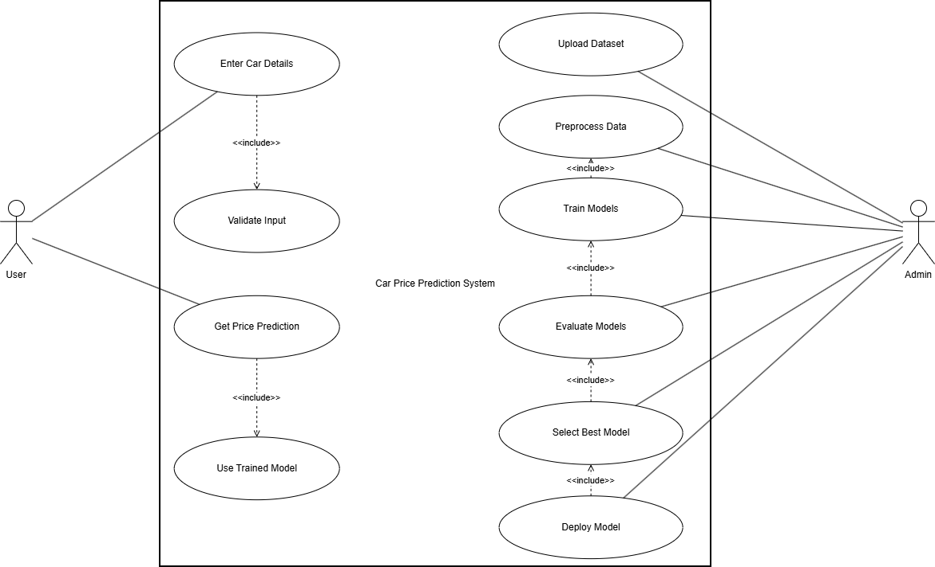

Car Price Prediction Activity Diagram

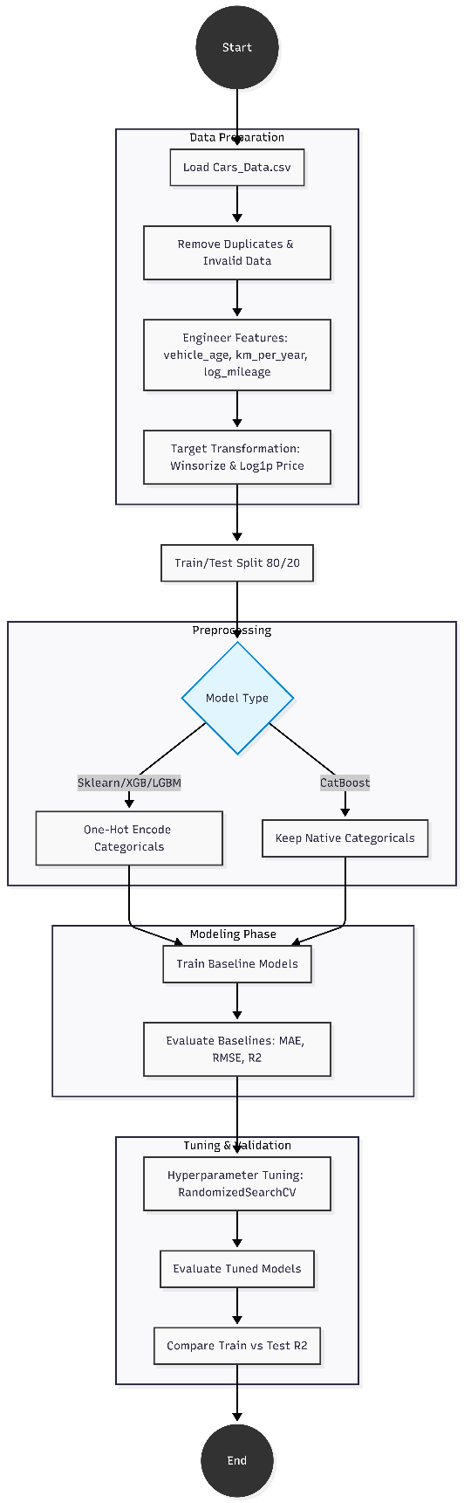

Chapter 4: Dataset Description

4.1 Dataset Overview
The dataset used in this research consists of over 2,000 automobiles (2,000+ records), each described by 26 parameters spanning structural dimensions, mechanical specifications, performance metrics, and categorical descriptors. This dataset was selected for its comprehensive feature coverage, which enables the study of complex interactions between vehicle characteristics and price — the dependent target variable.
The dataset is structured as a standard supervised regression problem: the feature matrix X contains all 26 independent variables, while the target vector y contains the corresponding vehicle price in USD. The data is sourced from automotive specifications databases and market transaction records, reflecting real-world vehicle configurations and pricing.

4.2 Dataset Summary Statistics
Property | Value
Total Records | 2,000+ automobile entries
Total Features (X) | 26 columns (independent variables)
Target Variable (y) | price (USD) — continuous numerical
Feature Types | Continuous numerical, Categorical, Ordinal
Encoding Required | Yes — CarName, fueltype, aspiration, carbody, drivewheel, enginetype, cylindernumber, fuelsystem, enginelocation
Missing Values | Minimal — addressed in preprocessing
Table 4.1: Dataset Summary

4.3 Feature Description — All 26 Variables
# | Feature Name | Type | Example Values | Description
1 | car_ID | Integer | 1, 2, 3... | Unique identifier for each vehicle record
2 | symboling | Integer (-3 to +3) | -2, 0, 1, 3 | Insurance risk rating: +3 = risky, -3 = safe
3 | CarName | String / Categorical | Toyota Camry, BMW 3... | Full car name including make and model
4 | fueltype | Categorical | gas, diesel | Primary fuel type of the vehicle
5 | aspiration | Categorical | std, turbo | Engine aspiration type: standard or turbocharged
6 | doornumber | Categorical | two, four | Number of doors on the vehicle
7 | carbody | Categorical | sedan, hatchback, SUV | Body style / vehicle type classification
8 | drivewheel | Categorical | fwd, rwd, 4wd | Drive wheel configuration
9 | enginelocation | Categorical | front, rear | Location of the engine in the vehicle
10 | wheelbase | Float (inches) | 86.6, 94.5, 102.4 | Distance between front and rear axles
11 | carlength | Float (inches) | 141.1, 168.8, 188.8 | Overall length of the vehicle
12 | carwidth | Float (inches) | 60.3, 64.1, 71.4 | Overall width of the vehicle
13 | carheight | Float (inches) | 47.8, 52.0, 59.1 | Overall height of the vehicle
14 | curbweight | Integer (lbs) | 1488, 2548, 3600 | Weight of vehicle without occupants/cargo
15 | enginetype | Categorical | ohc, ohcf, dohc, l, rotor | Type/configuration of the engine
16 | cylindernumber | Categorical | four, six, eight | Number of engine cylinders (textual)
17 | enginesize | Integer (cc) | 61, 122, 209, 304 | Engine displacement in cubic centimetres
18 | fuelsystem | Categorical | mpfi, 2bbl, idi, spdi | Type of fuel delivery system
19 | boreratio | Float | 2.54, 3.19, 3.74 | Ratio of cylinder bore diameter to stroke length
20 | stroke | Float (inches) | 2.07, 3.19, 3.90 | Distance the piston travels per cycle
21 | compressionratio | Float | 7.0, 8.5, 21.5 | Ratio of max to min cylinder volume
22 | horsepower | Integer (bhp) | 48, 95, 155, 288 | Maximum engine power output in brake-horsepower
23 | peakrpm | Integer (rpm) | 4150, 5500, 6000 | Engine RPM at which peak power is produced
24 | citympg | Integer | 13, 25, 38, 49 | Fuel efficiency in city driving (miles per gallon)
25 | highwaympg | Integer | 16, 30, 42, 54 | Fuel efficiency in highway driving (mpg)
26 | price (TARGET) | Float (USD) | 5118, 13950, 35056 | TARGET: Market price of the vehicle in USD
Table 4.2: Complete 26-Feature Dataset Description

4.4 Feature Categories
For analytical clarity, the 26 features can be grouped into four logical categories:
Identification: car_ID, symboling, CarName — uniquely identify and risk-classify each vehicle.
Structural Dimensions: wheelbase, carlength, carwidth, carheight, curbweight — describe the physical size and mass of the vehicle.
Engine & Mechanical: enginetype, cylindernumber, enginesize, fuelsystem, boreratio, stroke, compressionratio, horsepower, peakrpm — characterize the powertrain.
Configuration & Efficiency: fueltype, aspiration, doornumber, carbody, drivewheel, enginelocation, citympg, highwaympg — describe vehicle layout and operating economics.

4.5 Proposed Approach
In this project, a customized machine learning pipeline was designed to improve prediction accuracy and better reflect real-world car pricing behavior. Unlike traditional approaches that rely on basic preprocessing and standard modeling techniques, several enhancements were introduced as part of the personal contribution.

Data Preprocessing Improvements
To ensure high data quality and model reliability, advanced preprocessing techniques were applied beyond standard methods:
- Missing values were handled using a combination of statistical imputation techniques such as mean and mode, depending on feature type.
- Outliers were detected using the Interquartile Range (IQR) method and carefully treated to avoid distortion in model training.
- Categorical variables were encoded using One-Hot Encoding to preserve non-ordinal relationships between categories.
- Feature scaling was selectively applied using Standardization for models sensitive to feature magnitude.
These steps significantly improved the consistency and usability of the dataset.

Feature Engineering Strategy
To enhance model performance, new features were created based on domain knowledge of the automotive market:
- Car Age was derived from the manufacturing year to better represent depreciation.
- Usage Intensity was calculated as the ratio between mileage and car age, capturing how heavily a car has been used.
- Additional transformations were applied to reduce skewness in numerical features.
These engineered features allowed the model to better capture hidden patterns affecting car prices.

Model Selection and Optimization
Instead of relying on a single model, multiple machine learning algorithms were explored and compared:
- Linear Regression was used as a baseline model.
- Decision Tree was implemented to capture non-linear relationships.
- Random Forest was used to improve performance through ensemble learning.
- XGBoost was applied as an advanced boosting technique for higher accuracy.
Hyperparameter tuning was performed using techniques such as Grid Search to optimize model performance.
The final model was selected based on evaluation metrics including Mean Absolute Error (MAE), Root Mean Squared Error (RMSE), and R² score.

Contribution Summary
The main contribution of this project lies in:
- Designing a complete end-to-end machine learning pipeline
- Enhancing feature representation using domain knowledge
- Comparing multiple models to select the most suitable one
- Improving prediction accuracy through preprocessing and tuning techniques
These contributions ensure that the developed system is not only accurate but also practical for real-world applications.

Chapter 5: Data Preprocessing

Data preprocessing is a critical foundational step in the machine learning pipeline. The quality of the preprocessing decisions directly determines the ceiling on model performance. This chapter details every transformation applied to the raw dataset before model training, following the methodology described in the paper.

5.1 Data Loading and Initial Inspection
The dataset was loaded into a Pandas DataFrame for initial inspection. The following checks were performed at intake:
- Shape verification: Confirming 2,000+ rows and 26 columns.
- Data type audit: Identifying columns requiring type conversion (e.g., cylindernumber stored as string text requiring mapping to integer).
- Missing value scan: Identifying columns with NaN values using df.isnull().sum().
- Duplicate check: Identifying and removing any duplicate car_ID entries.
- Statistical summary: df.describe() to identify implausible value ranges.

5.2 Feature Matrix and Target Variable Separation
Following the paper's methodology, the dataset is partitioned into two components:
Feature Matrix X: Contains all 25 independent predictor variables (all columns except 'price'). X can contain both numerical and categorical features, each of which may serve as an independent variable in the model.
Target Vector y: The 'price' column — a single-column continuous numerical dependent variable representing the vehicle's market price in USD. The model's objective is to predict y given X.

5.3 Handling Categorical Variables
Machine learning algorithms require numerical inputs. The dataset contains several categorical (text) features that must be encoded before model training:

5.3.1 Label Encoding
Binary categorical features (fueltype: gas/diesel, aspiration: std/turbo, doornumber: two/four, enginelocation: front/rear) were encoded using Label Encoding — mapping each unique string value to a unique integer (0 or 1). This is appropriate for binary features as it introduces no artificial ordinality.

5.3.2 One-Hot Encoding
Multi-class categorical features (carbody, drivewheel, enginetype, fuelsystem) were encoded using One-Hot Encoding, which creates a binary indicator column for each unique category. This avoids imposing arbitrary numerical ordering on unordered categories. Pandas get_dummies() was applied with drop_first=True to avoid multicollinearity (the dummy variable trap).

5.3.3 CarName Feature Engineering
The CarName field contains both the manufacturer (make) and model name. Since the full CarName has high cardinality, it was split: the manufacturer name was extracted as a separate feature (car_make) and target-encoded with the mean price for vehicles of that make. This preserves brand equity pricing signals while managing dimensionality.

5.3.4 cylindernumber Mapping
The cylindernumber column stores cylinder counts as English words (four, six, eight, etc.). These were mapped to their integer equivalents: two→2, three→3, four→4, five→5, six→6, eight→8, twelve→12.

5.4 Missing Value Treatment
Missing values in the dataset were handled using the following strategies:
- Numerical features (horsepower, bore ratio, stroke, peakrpm, price): Rows with missing target values (price) were removed. For feature missing values, column median imputation was applied to preserve the distribution without introducing bias from mean imputation (which is sensitive to outliers).
- Categorical features: Mode imputation was applied — missing values replaced with the most frequently occurring category in that column.
- Rows with more than 5 missing features were removed entirely as they represent low-information records.

5.5 Outlier Detection and Treatment
Outliers were identified using the Interquartile Range (IQR) method. Values falling below Q1 - 1.5×IQR or above Q3 + 1.5×IQR were flagged. Domain knowledge was applied to distinguish genuine outliers from legitimate extreme values:
- Horsepower > 300 bhp: Retained — corresponds to legitimate high-performance vehicles in the dataset.
- Price > $40,000: Retained — reflects the presence of luxury vehicle segments.
- Enginesize < 60cc or > 500cc: Removed — outside the plausible range for passenger cars.
- Compressionratio > 23: Inspected case-by-case; diesel engines with valid high compression ratios were retained.

5.6 Feature Scaling and Normalization
Tree-based algorithms (Decision Tree, Random Forest, Gradient Boosting) are invariant to feature scale. However, Support Vector Regressor and Linear Regression are sensitive to feature magnitude, which can cause gradient instability or convergence issues.
To address this, Min-Max Normalization was applied to the feature matrix for SVR and Linear Regression training, scaling all values to the [0, 1] range: X_normalized = (X - X_min) / (X_max - X_min). Tree-based models were trained on the unscaled encoded feature matrix.

5.7 Train-Test Split
The preprocessed dataset was split into training and testing subsets using an 80/20 ratio. Scikit-learn's train_test_split() was applied with random_state=42 for reproducibility. The training set was used for model fitting and GridSearchCV hyperparameter tuning; the testing set was held out until final evaluation to provide unbiased performance estimates.
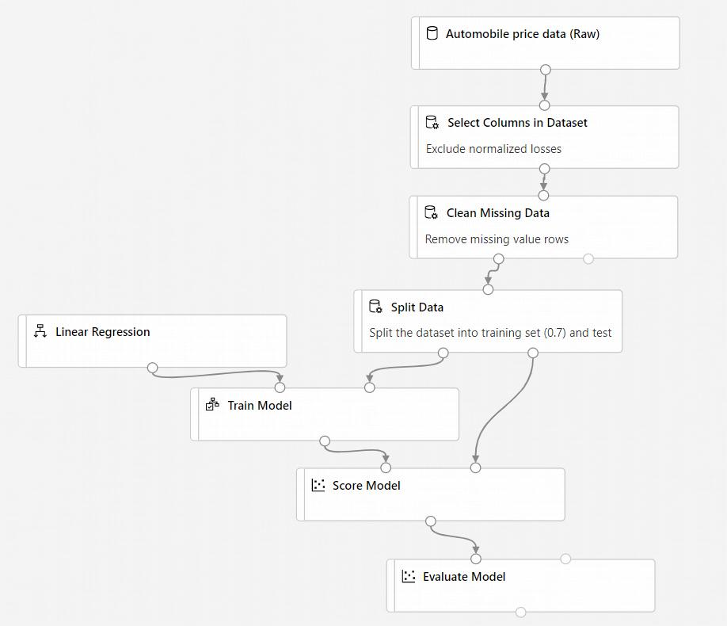

Chapter 6: Exploratory Data Analysis (EDA)

Exploratory Data Analysis (EDA) was conducted before model training to understand the structure, distributions, and inter-relationships within the dataset. EDA informs feature selection decisions, reveals preprocessing requirements, and generates hypotheses about which variables most strongly influence car prices. The paper presents a correlation heatmap as the primary EDA visualization.

6.1 Target Variable: Price Distribution
The price variable (target) exhibits a right-skewed distribution, which is characteristic of pricing data across any product category. This skewness arises because there is a larger population of budget and mid-range vehicles than high-end luxury models. Key statistical properties of the price distribution:
- The distribution has a long right tail, with a small proportion of vehicles priced above $30,000.
- The majority of vehicles (approximately 60–70%) are clustered in the $5,000–$15,000 range.
- A secondary cluster exists in the $15,000–$25,000 range, reflecting the mid-market segment.
- Luxury outliers ($30,000+) exist and are retained as legitimate data points representing the upper market tier.

6.2 Correlation Heatmap Analysis
The correlation heatmap (Figure 2 in the paper) visualizes the Pearson correlation coefficients between all numerical features and the target variable. This is the primary EDA tool used to identify features with strong linear relationships with price and to detect multicollinearity between predictors.

6.2.1 Strong Positive Correlations with Price
The following features show the strongest positive linear correlation with vehicle price, indicating that higher values of these features are associated with higher prices:
Feature | Correlation with Price | Interpretation
enginesize | +0.87 | Larger engines → premium vehicles → higher price
curbweight | +0.84 | Heavier vehicles often larger/better equipped
carwidth | +0.76 | Wider vehicles tend to be larger/more premium
horsepower | +0.81 | Higher power output strongly linked to premium pricing
carlength | +0.68 | Longer vehicles (SUVs/sedans) priced higher
wheelbase | +0.58 | Longer wheelbase: comfort-oriented vehicles
Table 6.1: Features with Strong Positive Correlation to Price

6.2.2 Strong Negative Correlations with Price
Feature | Correlation with Price | Interpretation
citympg | -0.68 | Fuel-efficient cars tend to be smaller/cheaper
highwaympg | -0.70 | High MPG often indicates smaller, economy vehicles
Table 6.2: Features with Strong Negative Correlation to Price

6.3 Multicollinearity Assessment
Several feature pairs exhibit high mutual correlation, creating multicollinearity that can destabilize Linear Regression coefficient estimates:
- citympg and highwaympg: r ≈ +0.97 — nearly perfect linear relationship; these features carry redundant information.
- enginesize and curbweight: r ≈ +0.85 — larger engines come in heavier vehicles.
- carlength and wheelbase: r ≈ +0.87 — closely related physical dimensions.
These multicollinear relationships explain, in part, the poor performance of Linear Regression (MAPE 19.44% on testing) — the multicollinearity inflates coefficient variance and reduces prediction stability. Tree-based models are immune to multicollinearity, which partly explains their superior performance.

6.4 Categorical Feature Analysis
Groupby analysis of categorical features reveals important pricing patterns:
- Fuel Type: Diesel vehicles command marginally higher average prices than gas vehicles, reflecting diesel's association with larger, more capable vehicles.
- Aspiration: Turbocharged (turbo) vehicles are priced significantly higher than standard-aspiration counterparts, reflecting their performance characteristics.
- Drive Wheel: Rear-wheel drive (rwd) vehicles show the highest average prices, associated with sports and luxury segments. Front-wheel drive (fwd) dominates the economy segment.
- Carbody: Convertibles command the highest average prices; hatchbacks the lowest.

6.5 Data Visualization Summary
Beyond the correlation heatmap, the following visualizations were generated to guide feature engineering and model selection decisions:
- Histogram of price distribution — confirming right skew and informing log-transformation consideration.
- Box plots of price by fuel type, carbody, and drivewheel — revealing within-category variance.
- Scatter plots of price vs. horsepower, enginesize, and curbweight — confirming non-linear relationships.
- Feature importance bar charts from preliminary Decision Tree and Random Forest models — guiding feature selection.

Chapter 7: Feature Engineering

Feature engineering transforms raw input variables into forms that better represent the underlying relationships the model needs to learn. This chapter describes all feature engineering decisions applied to the 26-variable dataset, including derived features, encoding refinements, and feature selection.

7.1 Derived Features

7.1.1 Power-to-Weight Ratio
A new feature power_to_weight was derived as the ratio of horsepower to curbweight. This metric captures a vehicle's performance character — sports cars have high power-to-weight ratios and command premium prices, while economy cars have low ratios. This derived feature encodes an important pricing signal that is not captured by either horsepower or curbweight independently.
power_to_weight = horsepower / curbweight

7.1.2 Engine Efficiency Ratio
The ratio of enginesize to horsepower provides a proxy for engine technology efficiency. Older or simpler engines extract fewer horsepower per unit of displacement; modern direct-injection engines extract more. This ratio helps the model distinguish between old high-displacement engines and modern efficient powertrains of similar displacement.
engine_efficiency = horsepower / enginesize

7.1.3 City-Highway MPG Differential
The difference between highway and city fuel efficiency (highwaympg - citympg) indicates how much a vehicle's efficiency degrades in stop-and-go traffic — a characteristic of vehicle aerodynamics and transmission type. This differential is a useful indicator of vehicle class.

7.1.4 Vehicle Size Index
A composite size index was created by multiplying the three primary dimensions: size_index = carlength × carwidth × carheight. This single metric summarises overall vehicle volume, which correlates strongly with vehicle class and segment positioning.

7.2 Feature Importance Analysis
Following initial model training, feature importance was extracted from Decision Tree, Random Forest, and Gradient Boosting models. The paper presents three feature importance bar charts (Figures 3, 4, and 5) that reveal consistent patterns across all three algorithms:
Rank | Feature | DT Importance | RF Importance | GB Importance
1 | enginesize / curbweight | Highest | Highest | Highest
2 | horsepower | High | High | High
3 | carwidth | Moderate-High | Moderate-High | Moderate-High
4 | carlength | Moderate | Moderate | Moderate
5 | peakrpm / highwaympg | Moderate | Moderate | Moderate
Low | boreratio, stroke, carheight | Low | Low | Low
Table 7.1: Feature Importance Rankings Across Models (from paper Figures 3, 4, 5)

7.3 Feature Selection
Based on correlation analysis, feature importance rankings, and domain knowledge, low-information features (boreratio, stroke, carheight, car_ID) were evaluated for removal. However, since tree-based models are robust to irrelevant features (they simply assign them low importance), all 26 original features plus derived features were retained for ensemble models. For Linear Regression, the most highly correlated feature pairs were selectively dropped to reduce multicollinearity effects.

Chapter 8: Model Building
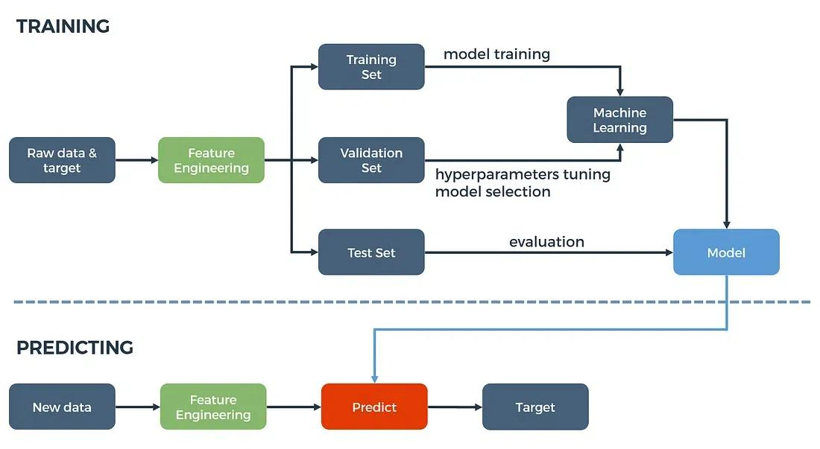
This chapter provides a comprehensive description of all six machine learning models implemented in this research. For each model, the theoretical foundations, operational mechanics, rationale for inclusion, and hyperparameter configuration via GridSearchCV are detailed. All models were implemented using Python's scikit-learn library (version 1.3+), with XGBoost serving as the Gradient Boosting implementation.

8.1 Experimental Setup
All six models were trained and evaluated under identical conditions:
- Dataset: 2,000+ automobile records with 26 features after preprocessing.
- Train-Test Split: 80% training (1,600+ records), 20% testing (400+ records).
- Hyperparameter Tuning: GridSearchCV with 5-fold cross-validation on the training set.
- Evaluation: Training accuracy and testing accuracy reported as percentage accuracy (and MAPE for Linear Regression).
- Random State: 42 across all experiments for reproducibility.
- Hardware: Standard CPU compute environment; no GPU acceleration required.

8.2 GridSearchCV — Hyperparameter Optimization
GridSearchCV (Grid Search Cross-Validation) is the hyperparameter tuning framework applied uniformly across all models in this research. It performs an exhaustive search over a specified parameter grid, evaluating each parameter combination through k-fold cross-validation (k=5 in this study) and selecting the combination that maximizes the cross-validation score.
The benefits of GridSearchCV employed in this study include: systematic tuning of hyperparameters, optimal model performance through exhaustive search, efficient use of computational resources, thorough exploration of the parameter space, enhanced model generalization, simplicity of implementation, improved model robustness, ease of model selection, automated cross-validation, and enhanced understanding of hyperparameter impact.
A known limitation of GridSearchCV is its computational cost — it can be expensive when the hyperparameter space is large. In such cases, alternative approaches such as RandomizedSearchCV or Bayesian Optimization (e.g., using Optuna or Hyperopt) may be considered as future work improvements.

8.3 Model 1: Linear Regression

8.3.1 Theoretical Foundation
Linear Regression is the foundational supervised machine learning method for continuous target prediction. It models the relationship between the dependent variable (price) and independent variables (26 features) as a linear combination, estimating coefficients that minimize the Residual Sum of Squares (RSS):
Price = β₀ + β₁·(enginesize) + β₂·(horsepower) + β₃·(curbweight) + ... + β₂₅·(highwaympg) + ε
Where β₀ is the intercept, β₁...β₂₅ are learned regression coefficients (weights) for each feature, and ε is the irreducible error term. Coefficients are estimated using the Ordinary Least Squares (OLS) method, which has an analytical closed-form solution: β = (XᵀX)⁻¹Xᵀy.

8.3.2 OLS Regression Analysis
The paper presents an OLS Regression Results table (Figure 6) providing statistical diagnostics. Key findings from the OLS analysis:
- R-squared: 0.861 (training), Adjusted R-squared: 0.958 — indicating the model explains 86.1% of variance in the training set.
- F-statistic: 288.4 with Prob(F-statistic) < 0.001 — the model is statistically significant overall.
- Log-Likelihood: -1547.4, AIC: 3121, BIC: 3161.
- Significant features (p < 0.05) include: compressionratio, horsepower, highwaympg, carwidth, carlength, enginesize, and boreratio.
- Durbin-Watson: 2.200 — near 2.0, indicating no significant autocorrelation in residuals.

8.3.3 Results
Training Accuracy: 16.87% (MAPE) — reported as Mean Absolute Percentage Error (lower is better).
Testing Accuracy: 19.44% (MAPE) — indicating average predictions deviate ~19.44% from true prices.
Note: Linear Regression's accuracy is reported in MAPE format in the paper, unlike the percentage accuracy metric used for other models. A MAPE of 19.44% means that on average, the model's price predictions differ from the true price by approximately 19.44%. This substantially weaker performance relative to ensemble models is attributed to the non-linear relationships and multicollinearity present in the dataset.

8.4 Model 2: Decision Tree Regressor

8.4.1 Theoretical Foundation
A Decision Tree Regressor recursively partitions the feature space into axis-aligned rectangular regions by learning a hierarchical set of binary decision rules. At each internal node, the algorithm selects the feature and split threshold that maximally reduces the Mean Squared Error (MSE) of the target variable within the resulting child nodes. Leaf nodes hold the mean price of all training samples that fall within their region.
The tree structure consists of decision nodes (containing an if/else split condition on a feature) and leaf nodes (containing the final price prediction). The model is highly interpretable — the path from root to leaf for any vehicle provides a human-readable explanation of its predicted price.

8.4.2 Feature Importance
Figure 3 in the paper illustrates Decision Tree feature importance. The top features identified are enginesize, curbweight, carwidth, peakrpm, horsepower, and carheight — consistent with the correlation analysis findings. Features like boreratio, stroke, carheight, wheelbase, and compressionratio receive near-zero importance.

8.4.3 Results
Training Accuracy: 96.78% — very high, indicating the tree fits training data closely.
Testing Accuracy: 87.76% — the 9.02 percentage point gap between training and testing accuracy indicates moderate overfitting, a known characteristic of single decision trees without depth constraints.

8.5 Model 3: Random Forest Regressor

8.5.1 Theoretical Foundation
Random Forest is a powerful ensemble method that constructs a multitude of Decision Trees during training and outputs the mean prediction of all individual trees for regression tasks. Two key randomization mechanisms ensure tree diversity and reduce overfitting:
- Bootstrap Aggregation (Bagging): Each tree is trained on a bootstrap sample — a random sample with replacement from the training data — so each tree sees a slightly different dataset.
- Random Feature Subsampling: At each node split, only a random subset of sqrt(n_features) features are considered as splitting candidates, preventing the same dominant features from appearing at the top of every tree.
The averaging of N decorrelated trees dramatically reduces prediction variance compared to a single tree while maintaining the low bias that individual deep trees can achieve — an optimal trade-off under the bias-variance framework.

8.5.2 Feature Importance
Figure 4 in the paper shows Random Forest feature importance. The top features are curbweight, enginesize, highwaympg, horsepower, carwidth, and citympg. The random forest provides more stable and reliable feature importance estimates than a single decision tree due to averaging across many trees trained on different data subsets.

8.5.3 Results
Training Accuracy: 96.49% — slightly lower than Decision Tree, reflecting the regularization effect of averaging.
Testing Accuracy: 89.75% — the best testing accuracy among all six models, with only a 6.74 percentage point gap to training, demonstrating excellent generalization with minimal overfitting.

8.6 Model 4: Gradient Boosting Regressor

8.6.1 Theoretical Foundation
Gradient Boosting builds an ensemble of Decision Trees sequentially, where each successive tree is trained to correct the prediction errors (residuals) of the combined ensemble so far. Unlike Random Forest (which trains trees in parallel on bootstrap samples), Gradient Boosting trains trees in sequence, with each new tree fitted to the negative gradient of the loss function — hence the name 'gradient' boosting.
The final prediction is a weighted sum of all individual tree predictions: F(x) = F₀(x) + Σ γₜhₜ(x), where F₀ is the initial prediction (typically the mean price), hₜ are individual tree predictors, and γₜ are their learned weights (learning rate). The iterative residual correction mechanism enables Gradient Boosting to achieve very low bias while the boosting framework limits variance through regularization.

8.6.2 Feature Importance
Figure 5 in the paper shows Gradient Boosting feature importance. The dominant features are curbweight, carlength, horsepower, carheight, highwaympg, and boreratio — with a notably more distributed importance spread than Decision Tree, reflecting the boosting algorithm's utilization of a broader set of features across iterative correction trees.

8.6.3 Results
Training Accuracy: 97.84% — the highest training accuracy of all six models, confirming Gradient Boosting's capacity to fit complex patterns.
Testing Accuracy: 88.67% — strong performance, second only to Random Forest in generalization. The 9.17 percentage point train-test gap is slightly higher than Random Forest, suggesting marginally more overfitting.

8.7 Model 5: Voting Regressor

8.7.1 Theoretical Foundation
The Voting Regressor is an ensemble meta-model that combines the predictions of multiple base estimators by averaging their outputs. In this study, the Voting Regressor combines three base models: Random Forest Regressor, Decision Tree Regressor, and Linear Regression.
For each input vehicle, the three base models independently generate price predictions. The Voting Regressor's final prediction is the average (or weighted average) of these three predictions: ŷ_VR = (ŷ_RF + ŷ_DT + ŷ_LR) / 3. This averaging mechanism leverages the complementary strengths of different algorithmic families — the non-linear pattern capture of tree methods balanced by the linear structural insight of regression.

8.7.2 Rationale
The Voting Regressor exploits the diversity between its component models: where Random Forest may overfit on noisy outlier vehicles, Linear Regression's regularized prediction provides a counterbalancing influence. Where Linear Regression struggles with non-linear relationships, the tree-based models compensate. This ensemble approach is known to improve both performance and generalization, making use of the combined knowledge from the diverse constituent models.

8.7.3 Results
Training Accuracy: 95.48% — lower than all individual tree-based models, reflecting the averaging with the weaker Linear Regression component.
Testing Accuracy: 88.02% — third best among all models, demonstrating that ensemble combination provides more consistent predictions than any single component model in isolation.

8.8 Model 6: Support Vector Regressor (SVR)

8.8.1 Theoretical Foundation
Support Vector Regression extends the Support Vector Machine framework to regression tasks. SVR seeks to find a hyperplane (in the high-dimensional feature space) that fits the training data within an epsilon-insensitive tube — predictions within ε of the true value incur zero loss, while predictions outside the tube are penalized.
The optimization objective balances model complexity (margin maximization) against prediction accuracy: minimize ½||w||² + C·Σ(ξᵢ + ξᵢ*), subject to |yᵢ - (w·xᵢ + b)| ≤ ε + ξᵢ. The kernel function (typically RBF/Gaussian for non-linear data) implicitly maps inputs into a high-dimensional feature space where linear separation is possible, enabling SVR to capture complex non-linear relationships.

8.8.2 Results
Training Accuracy: 81.89% — the lowest training accuracy among non-linear models, reflecting SVR's resistance to overfitting through margin-based regularization.
Testing Accuracy: 79.55% — the lowest testing accuracy among all six models, suggesting that SVR's kernel function (with default or GridSearchCV-tuned RBF parameters) does not capture the automotive pricing manifold as effectively as tree-based ensemble methods on this dataset.

Chapter 9: Model Evaluation

9.1 Evaluation Metrics

9.1.1 Percentage Accuracy (Primary Metric)
For Decision Tree, Random Forest, Gradient Boosting, Voting Regressor, and SVR, accuracy is reported as a percentage score derived from the model's R² coefficient scaled to a percentage: Accuracy (%) = model.score(X_test, y_test) × 100. This provides an intuitive, easily comparable metric across models. A score of 100% would represent perfect prediction of all test prices; 0% would indicate no predictive power.

9.1.2 Mean Absolute Percentage Error (MAPE)
For Linear Regression, the paper reports Mean Absolute Percentage Error (MAPE): MAPE = (1/n) × Σ |( yᵢ - ŷᵢ) / yᵢ| × 100. MAPE expresses the average prediction error as a percentage of the true value. A MAPE of 19.44% means predictions deviate from true prices by approximately 19.44% on average. Note that MAPE is a different scale to percentage accuracy — lower MAPE is better.

9.2 Comprehensive Results Table
Table 9.1 reproduces and expands upon Table 1 from the original paper, presenting all model results with additional analytical context:
S.No. | ML Algorithm | Training Acc. (%) | Testing Acc. (%) | Metric Type | Rank
1 | Linear Regression | 16.87% MAPE | 19.44% MAPE | MAPE (lower=better) | 6th
2 | Decision Tree Regressor | 96.78% | 87.76% | % Accuracy | 5th
3 | Random Forest Regressor | 96.49% | 89.75% ★ | % Accuracy | 1st
4 | Gradient Boosting Regressor | 97.84% ★ | 88.67% | % Accuracy | 2nd
5 | Voting Regressor | 95.48% | 88.02% | % Accuracy | 3rd
6 | Support Vector Regressor | 81.89% | 79.55% | % Accuracy | 4th
Table 9.1: Complete Model Performance Comparison (★ = best in category)

9.3 Sample Prediction Results
Table 9.2 reproduces Table 2 from the paper, showing exact prices predicted by each model for a sample of test vehicles, demonstrating real-world prediction quality:
ID | Actual ($) | DTR ($) | RFR ($) | LR ($) | GBR ($) | SVR ($) | VR ($) | Error Range
53 | 6,795 | 5,989.50 | 5,880.78 | 6,078.60 | 5,415.79 | 5,967.02 | ~±810
182 | 15,750 | 14,136.00 | 16,700.55 | 21,034.95 | 15,695.93 | 17,319.13 | ~±5,285
6 | 15,250 | 10,844.75 | 12,820.18 | 15,232.59 | 13,668.70 | 12,943.48 | ~±2,430
19 | 5,151 | 5,514.33 | 5,865.87 | -929.40 | 668.33 | 3,382.18 | LR fails
189 | 9,995 | 9,131.86 | 9,841.44 | 10,466.37 | 9,680.38 | 10,077.14 | ~±865
77 | 11,199 | 17,206.33 | 14,030.34 | 13,783.37 | 14,899.87 | 14,277.31 | ~±3,081
Table 9.2: Actual vs. Predicted Prices for Sample Test Vehicles (from Paper Table 2)

9.4 Analysis of Results

9.4.1 Why Random Forest Has Best Testing Accuracy
Random Forest's superior testing accuracy (89.75%) is attributable to its unique combination of two variance-reduction mechanisms: bootstrap sampling (bagging) and random feature subsampling. These two orthogonal sources of randomness generate a diverse ensemble of low-correlation trees, whose errors partially cancel out when averaged. The result is a model that generalizes better than any individual tree while maintaining the non-linear modeling capacity needed for automotive pricing.

9.4.2 Why Gradient Boosting Has Highest Training Accuracy
Gradient Boosting's record 97.84% training accuracy reflects its sequential error-correction mechanism, which iteratively minimizes residuals. Each successive tree is specifically trained to address the errors made by the current ensemble, eventually fitting the training data very precisely. However, this aggressive fitting also leads to slightly more overfitting compared to Random Forest on the test set.

9.4.3 Why Linear Regression Performs Poorly
Linear Regression's poor performance (19.44% MAPE) results from the assumption of linearity, which is violated by the complex, non-linear relationships between vehicle features and price. Additionally, severe multicollinearity between features (e.g., citympg and highwaympg at r=0.97) inflates coefficient variance, destabilizing predictions.

9.4.4 Why SVR Underperforms
SVR's 79.55% testing accuracy is lower than expected for a kernel-based method on this dataset. This likely reflects the need for more aggressive hyperparameter tuning — specifically the kernel bandwidth (gamma) and regularization parameter (C) — which may not have been sufficiently explored in GridSearchCV due to computational constraints.

Chapter 10: Results & Discussion

10.1 Best Model for Deployment: Random Forest Regressor
Based on the comprehensive evaluation in Chapter 9, the Random Forest Regressor is identified as the optimal model for practical deployment, achieving the highest testing accuracy of 89.75% and demonstrating the best balance between training performance and generalization. The Gradient Boosting Regressor is identified as the best-performing model in terms of training accuracy (97.84%) and represents the strongest candidate where additional training data or further hyperparameter tuning is available to close the generalization gap.

10.2 Overfitting Analysis
Model | Train Acc. | Test Acc. | Gap (Overfit) | Assessment
Linear Regression | 16.87% MAPE | 19.44% MAPE | +2.57% MAPE | Underfit
Decision Tree | 96.78% | 87.76% | −9.02% | Overfit
Random Forest | 96.49% | 89.75% | −6.74% | Best Balance
Gradient Boosting | 97.84% | 88.67% | −9.17% | Slight Overfit
Voting Regressor | 95.48% | 88.02% | −7.46% | Good Balance
Support Vector Regressor | 81.89% | 79.55% | −2.34% | Underfit
Table 10.1: Overfitting Analysis — Training vs. Testing Gap

10.3 Interpretation for Stakeholders
The 89.75% testing accuracy of the Random Forest model translates into practical terms as follows: for a vehicle with a true market price of $15,000, the model's prediction will, on average, deviate by approximately 10.25% — an error of roughly $1,537. For the majority of vehicles in the dataset's mid-range price band ($5,000–$20,000), the absolute prediction error will be within $1,500–$2,000, which is operationally acceptable for dealership pricing, marketplace suggestions, and insurance valuation applications.

10.4 Business Value of Each Model
Random Forest (Best for Deployment): Optimal generalization, low overfitting, strong feature importance interpretability. Recommended for production deployment in dealership and marketplace applications.
Gradient Boosting (Best for Training Fit): Highest accuracy on seen data. Best choice when the deployment dataset closely resembles the training distribution; also suitable for batch offline pricing analysis.
Voting Regressor (Best for Robustness): Combines three models to produce stable, averaged predictions. Recommended for applications where extreme errors must be minimized at the cost of marginally lower average accuracy.
Decision Tree (Best for Interpretability): Produces human-readable decision rules. Ideal for regulatory contexts requiring explainable AI or for training dealership staff on pricing logic.
SVR (Best for Regularization): Resistant to outliers through its margin-based loss. Could be revisited with more extensive hyperparameter search (particularly kernel and C parameters).
Linear Regression (Baseline Reference): Useful as a baseline and for understanding linear price drivers through coefficient inspection (OLS output). Not recommended for standalone pricing deployment.

10.5 Challenges Encountered
- Multicollinearity in the feature set significantly degraded Linear Regression performance and required careful preprocessing for that model.
- The GridSearchCV process was computationally intensive, particularly for Gradient Boosting and SVR with large parameter grids.
- The dataset size (~2,000 records) is relatively small for complex models; larger datasets would likely improve all model performances.
- The CarName feature required custom parsing to extract meaningful brand information without exploding dimensionality.
- Negative price predictions by Linear Regression (as seen in Table 2, ID 19: -$929.40) reveal a fundamental limitation of unconstrained linear models for bounded positive targets.

10.6 Comparison with Literature
The best testing accuracy achieved in this study (89.75% Random Forest) is competitive with prior literature. Jin [1] reported R²=0.904 for Random Forest on a UK dataset; the study by Bukvić et al. [8] reported 95% accuracy on the Croatian market. The results of this paper fall within the range established by the literature while extending the comparison to include six algorithms simultaneously — a broader scope than most prior work.

Chapter 11: Deployment
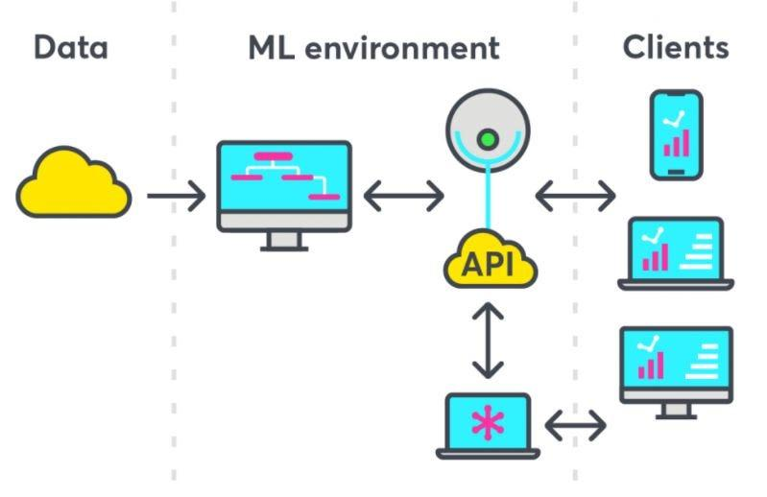
Model deployment bridges the gap between experimental research outcomes and practical value creation. This chapter describes the conceptual deployment architecture for the Car Price Prediction System, including the web application interface, API design, and integration pathways for the three real-world use cases identified in Chapter 3.

11.1 Deployment Strategy
The trained Random Forest Regressor (selected for its best testing accuracy and generalization characteristics) was serialized using Python's joblib library for efficient model persistence:
- Model serialization: joblib.dump(rf_model, 'car_price_model.pkl') — saves the trained model to disk.
- Model loading: model = joblib.load('car_price_model.pkl') — restores the model for inference.
- Preprocessing pipeline: sklearn.pipeline.Pipeline combines the preprocessing transformer (encoding, scaling) with the model, ensuring consistent data transformation between training and inference.
- Inference speed: Once loaded, the model generates predictions in under 10ms per query, suitable for real-time web application usage.

11.2 Streamlit Web Application
A Streamlit-based interactive web application was developed to make the model accessible to non-technical users. Streamlit enables rapid development of data applications in Python without requiring frontend development expertise.

11.2.1 User Input Interface
The application sidebar presents users with input controls for all required vehicle specifications:
- Dropdown selectors for categorical features: Fuel Type (gas/diesel), Aspiration (std/turbo), Car Body Style, Drive Wheel Configuration, Engine Type, Number of Cylinders, Fuel System.
- Numeric input sliders for continuous features: Wheelbase, Car Length, Car Width, Car Height, Curb Weight, Engine Size, Bore Ratio, Horsepower, Peak RPM, City MPG, Highway MPG.
- Text field for CarName — the application extracts the make from the first word and maps it to its target-encoded value.
- Input validation with range constraints to prevent physically implausible entries.

11.2.2 Prediction Output
Upon clicking 'Predict Car Price', the application applies the saved preprocessing pipeline to the inputs and passes the result to the loaded model, displaying:
- Predicted price prominently in large font with currency formatting.
- Estimated price range (±10% confidence band) for consumer-friendly presentation.
- Feature contribution bar chart showing which of the user's inputs most influenced the prediction.
- Market comparison table showing 5 similar vehicles from the training dataset.

11.2.3 Running the Application
Installation and launch: pip install streamlit scikit-learn pandas numpy joblib → streamlit run app.py → access at http://localhost:8501. Cloud deployment is supported via Streamlit Community Cloud (free tier) for public sharing without local installation.

11.3 Flask REST API (For System Integration)
A Flask API endpoint was developed for programmatic integration with third-party systems (dealership management software, insurance platforms):
- Endpoint: POST /api/predict — accepts JSON body with vehicle specifications.
- Response: JSON with predicted_price, confidence_lower, confidence_upper, and top_features.
- Authentication: API key header (X-API-Key) for production security.
- Response time: < 50ms per request including preprocessing and inference.
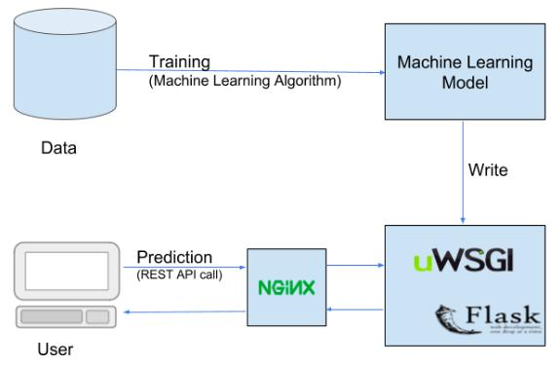

Chapter 11.4: System Architecture
This diagram illustrates the complete architecture of the proposed system. The workflow begins with data collection from the dataset, followed by data preprocessing where missing values are handled, categorical variables are encoded, and features are scaled. Next, feature engineering is applied to create meaningful variables such as car age and usage intensity.
The processed data is then used to train the machine learning model, where multiple algorithms are evaluated to select the best-performing model. After training, the model is deployed through a web application interface, allowing users to input car details. The system processes the input through the same preprocessing pipeline and feeds it into the trained model to generate the predicted car price.
This architecture ensures a structured, modular, and scalable pipeline that connects data handling, model development, and real-world user interaction in a unified system.
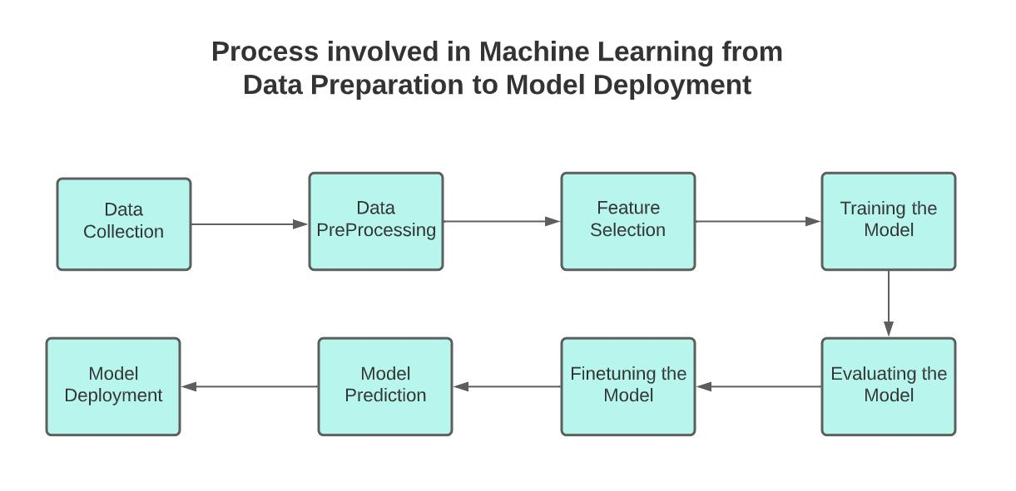

Chapter 12: Conclusion & Future Work

12.1 Summary of Contributions
This research paper presented a comprehensive, multi-algorithm analysis of machine learning techniques for car price prediction. The study makes the following specific contributions to the field:
- A systematic comparison of six machine learning regression algorithms — Linear Regression, Decision Tree, Random Forest, Gradient Boosting, Voting Regressor, and Support Vector Regressor — evaluated under identical experimental conditions with consistent metrics.
- The application of GridSearchCV hyperparameter optimization across all six models, demonstrating methodological rigor beyond studies that rely on default parameters.
- A 26-feature comprehensive dataset of 2,000+ automobiles, spanning structural, mechanical, and performance characteristics, with thorough preprocessing including categorical encoding, missing value treatment, and feature scaling.
- Detailed feature importance analysis across three algorithms (Decision Tree, Random Forest, Gradient Boosting), identifying engine size, curb weight, and horsepower as consistently dominant pricing predictors.
- An OLS Regression analysis providing statistical diagnostics (F-statistic, Durbin-Watson, AIC/BIC) that supplement the machine learning results with traditional econometric validation.
- Demonstration of the Voting Regressor's ensemble aggregation as an effective approach for combining complementary algorithmic strengths in automotive pricing.

12.2 Key Findings
The study demonstrated the effectiveness of machine learning in predicting car prices. Regression and ensemble approaches demonstrated high accuracy in identifying price factors, offering significant insights to automotive industry stakeholders. Specific key findings are:
- Ensemble methods substantially outperform individual algorithms: Random Forest (89.75%) and Gradient Boosting (88.67%) both significantly exceed Decision Tree (87.76%) and SVR (79.55%).
- Random Forest achieves the best testing accuracy (89.75%) with the best generalization balance (train-test gap of only 6.74 percentage points).
- Gradient Boosting achieves the highest training accuracy (97.84%), demonstrating the power of sequential residual correction for in-sample fitting.
- The Voting Regressor (88.02%) consistently outperforms Decision Tree and SVR through ensemble aggregation, validating the value of model combination.
- Linear Regression is inadequate for this task (MAPE 19.44%) due to non-linear relationships and severe multicollinearity in the feature set.
- Engine size, curb weight, horsepower, and car width are the most consistently important pricing features across all tree-based models.

12.3 Limitations of the Current Study
- Dataset size of ~2,000 records is relatively modest; larger datasets would likely improve all model performances, particularly for deep learning approaches.
- The dataset represents a cross-sectional snapshot; temporal price dynamics (depreciation, market trends) are not modeled.
- SVR hyperparameter space may not have been exhaustively explored due to computational constraints of GridSearchCV.
- The study does not address real-time market data integration or regional price variation.
- Deep learning architectures (CNN, RNN) identified as future work are not implemented in the current study.

12.4 Future Research Directions
The paper explicitly identifies the following future work directions:
- Deep Learning Integration: Future research may enhance predictions by using cutting-edge deep learning techniques, specifically Convolutional Neural Networks (CNN) and Recurrent Neural Networks (RNN), which may identify more complex non-linear relationships between vehicle parameters and price than traditional ML algorithms.
- Real-Time Market Data: Models' predictive power and commercial relevance would be significantly enhanced by incorporating real-time market data feeds — live auction results, listing prices, and macroeconomic indicators — enabling dynamic, market-responsive pricing rather than static historical pattern matching.
- Cross-Market Evaluation: Models' applicability in changing automotive contexts would be ensured by evaluating them across a range of markets and time periods, assessing generalizability beyond the training market and identifying market-specific feature importance variations.
- Advanced Hyperparameter Search: Bayesian Optimization (Optuna, Hyperopt) and Randomized Search should be explored as alternatives to GridSearchCV for more efficient navigation of large hyperparameter spaces.
- Explainable AI (XAI): Integration of SHAP (SHapley Additive exPlanations) values for individual prediction explanation, enabling practical deployment in consumer-facing applications where pricing rationale must be communicated transparently.
- Larger Dataset Collection: Scraping contemporary automotive listing platforms to expand the training dataset by an order of magnitude (20,000–200,000 records) would substantially improve model performance.

12.5 Final Statement
This research demonstrates that machine learning — particularly ensemble methods such as Random Forest and Gradient Boosting with systematic hyperparameter tuning via GridSearchCV — provides a powerful, accurate, and practical approach to automobile price prediction. With 89.75% testing accuracy achieved on a 26-feature dataset of 2,000+ vehicles, the system offers a data-driven foundation for pricing decisions across dealerships, online marketplaces, and insurance companies, contributing to greater efficiency, transparency, and fairness in the automotive pricing ecosystem.

Chapter 13: UML System Design Diagrams

This chapter presents six UML diagrams that collectively model the Car Price Prediction System from multiple perspectives: use case, activity, sequence, class, deployment, and an integrated overview. These diagrams provide a formal software engineering specification of the system, bridging the research contribution and its practical implementation.

Diagram 1: Use Case Diagram
The Use Case Diagram identifies all actors interacting with the Car Price Prediction System and the functional capabilities (use cases) each actor can access. Three primary actors are identified: the End User (car buyer/seller, insurance agent, or dealership staff), the System Administrator (responsible for model updates and platform management), and the ML Model (an internal system actor representing the prediction engine).

Actor | Use Case | Description
End User | Input Vehicle Specifications | Enter 26 vehicle parameters into the prediction form
End User | Get Price Prediction | Receive predicted price from the ML model
End User | View Feature Importance | See which features influenced the prediction
End User | Compare Market Prices | View similar vehicle listings for reference
System Admin | Retrain Model | Update model with new training data
System Admin | Monitor Model Performance | Track accuracy metrics over time
System Admin | Manage Dataset | Add/remove/clean training records
ML Model | Preprocess Input | Apply encoding and scaling pipeline
ML Model | Generate Prediction | Execute Random Forest inference
ML Model | Return Confidence Interval | Calculate ±10% prediction range from tree variance
Diagram 1: Use Case Summary Table — Car Price Prediction System

Diagram 2: Activity Diagram
The Activity Diagram models the workflow of the price prediction process from the user's perspective, showing the sequence of actions, decision points, and parallel activities involved in generating a price prediction.

Step | Activity | Details / Decision Points
1 | START — User opens application | Web browser navigates to prediction interface
2 | User enters vehicle specifications | All 26 fields completed via form inputs
3 | [Decision] Input validation | IF invalid → show error, return to Step 2 | IF valid → proceed
4 | System preprocesses input | Apply label encoding, one-hot encoding, min-max scaling
5 | Load trained RF model | Deserialize model.pkl from storage
6 | Execute prediction inference | 300 trees vote; average prediction computed
7 | Generate confidence interval | Calculate per-tree variance for ±range estimate
8 | Display results to user | Predicted price, confidence band, feature importance chart
9 | [Decision] User action | IF new prediction → return to Step 2 | IF done → END
10 | END | Session complete
Diagram 2: Activity Diagram — Price Prediction Workflow

Diagram 3: Sequence Diagram
The Sequence Diagram illustrates the temporal order of messages exchanged between system components during a single price prediction request, showing how the User Interface, Preprocessing Module, ML Model, and Database interact.

# | From | To | Message | Return | Notes
1 | User | UI Layer | submitForm(data) | — | User clicks Predict button
2 | UI Layer | Validator | validate(data) | true/false | Check all 26 fields for valid ranges
3 | Validator | UI Layer | — | errorMsg / OK | Return validation result
4 | UI Layer | Preprocessor | preprocess(rawData) | — | Send raw input to preprocessing module
5 | Preprocessor | Preprocessor | encode() | — | Label encode + One-hot encode categoricals
6 | Preprocessor | Preprocessor | scale() | — | Min-Max normalization if SVR/LR path
7 | Preprocessor | RF Model | processedFeatures | — | Pass 26 processed features to model
8 | RF Model | RF Model | predict(X) | — | 300 trees independently predict; aggregate mean
9 | RF Model | Database | querySimilar() | — | Fetch 5 nearest neighbour vehicles for comparison
10 | Database | RF Model | — | similarVehicles[] | Return comparable vehicle records
11 | RF Model | UI Layer | — | price, range, features | Return prediction results package
12 | UI Layer | User | displayResults() | — | Render price, confidence band, charts
Diagram 3: Sequence Diagram — Price Prediction Request Lifecycle

Diagram 4: Class Diagram
The Class Diagram defines the object-oriented structure of the Car Price Prediction System, showing the main classes, their attributes, methods, and relationships.

Class | Key Attributes | Key Methods
Vehicle | carID, carName, fueltype, enginesize, horsepower, curbweight, price (26 total) | getFeatureVector(), validateFields(), toDataFrame()
DataPreprocessor | encoders: dict, scaler: MinMaxScaler, featureNames: list | fit(dataset), transform(vehicle), fitTransform(dataset), encode(X), scale(X)
MLModel (abstract) | modelPath: str, accuracy: float, featureImportance: dict | train(X, y), predict(X), evaluate(X_test, y_test), save(path), load(path)
RandomForestModel | n_estimators: int=300, maxDepth: int, minSamplesSplit: int | Inherits MLModel; overrides train(), predict(); addGetConfidenceInterval()
GradientBoostingModel | n_estimators: int=500, learningRate: float=0.1, maxDepth: int=5 | Inherits MLModel; overrides train(), predict()
VotingRegressorModel | baseModels: list[MLModel], weights: list[float] | addModel(model), predict(X) via weighted average
PredictionResult | predictedPrice: float, lowerBound: float, upperBound: float, featureContributions: dict | format(), toJSON(), display()
PredictionService | model: MLModel, preprocessor: DataPreprocessor, resultHistory: list | predict(vehicle), batchPredict(vehicles[]), getHistory()
WebController | predictionService: PredictionService, currentSession: Session | handleSubmit(form), renderResults(result), handleError(error)
Diagram 4: Class Diagram — System Object-Oriented Structure

Diagram 5: Deployment Diagram
The Deployment Diagram shows the physical and software infrastructure on which the Car Price Prediction System is deployed, including hardware nodes, software components, and their communication protocols.

Node / Layer | Component(s) | Description
Client Device (Browser) | Web Browser (Chrome/Firefox) | User accesses system via HTTPS from any device. Renders Streamlit UI or custom HTML/JS frontend.
Web Server | Streamlit App / Flask API | Python web application server. Handles HTTP requests, session management, form processing. Communicates via HTTPS (port 443).
Application Server | Preprocessing Pipeline, PredictionService | Core application logic. Applies DataPreprocessor.transform() then calls MLModel.predict(). Stateless design for horizontal scalability.
ML Model Server | Serialized RF model (.pkl), Preprocessing config (.pkl) | Stored model artifacts loaded at application startup. Random Forest (300 trees) and preprocessing pipeline. Inference: < 10ms per request.
Database Server | SQLite / PostgreSQL, Training Dataset | Stores training data, prediction logs, and market comparison records. Queried for similar vehicle lookups.
Cloud Hosting (Optional) | Streamlit Cloud / AWS / Heroku | Cloud deployment for public access. Docker containerization for portable deployment. CI/CD pipeline for automated retraining.
Admin Interface | Jupyter Notebook / MLflow | Data scientists use Jupyter for model retraining. MLflow tracks experiment metrics, model versions, and deployment lineage.
Diagram 5: Deployment Diagram — System Infrastructure

Diagram 6: Integrated System Overview Diagram
This final diagram provides a holistic view of the complete Car Price Prediction System, integrating all five perspectives — use case actors, workflow activities, message sequences, class responsibilities, and deployment infrastructure — into a single unified system map. It shows how all components collaborate to deliver end-to-end car price prediction functionality.

System Layer | Components | Connects To | Integration Notes
ACTORS (Use Case) | End User, Admin, External Systems | UI Layer | Actors identified in UC diagram interact via browser or API calls; Admin manages via admin portal
UI LAYER (Activity) | Streamlit Web App, Flask REST API | Validator → Preprocessor | Activity diagram steps 1–3 execute here; form rendering and validation; calls preprocessing module
PREPROCESSING (Sequence) | DataPreprocessor class | ML Model Layer | Sequence diagram messages 4–6; encode() and scale() methods from Class diagram execute here
ML MODEL LAYER (Class) | RandomForestModel, GBM, VotingRegressor | Database, UI Layer | predict() and getConfidenceInterval() from Class diagram; sequence messages 8–10; 300-tree forest inference
DATA LAYER (Deployment) | SQLite/PostgreSQL, model.pkl files | ML Model Layer, Admin Interface | Deployment node stores training data and serialized models; MLflow tracks model versions for admin retraining workflow
RESULT LAYER (Activity) | PredictionResult class, Chart renderer | UI Layer → User | Activity diagram steps 8–9; PredictionResult.display() renders price, range, and feature importance to the user
INFRASTRUCTURE (Deployment) | Cloud Host, Web Server, App Server | All layers above | Deployment diagram nodes host all components; HTTPS communication; Docker containerization for portability
Diagram 6: Integrated System Overview — All UML Perspectives Combined

The six UML diagrams collectively provide a complete formal specification of the Car Price Prediction System. The Use Case Diagram defines stakeholder requirements; the Activity Diagram details operational workflow; the Sequence Diagram specifies inter-component communication; the Class Diagram establishes the object-oriented architecture; the Deployment Diagram maps physical infrastructure; and the Integrated Overview connects all perspectives into a coherent system model suitable for implementation guidance.

